Market Analysis for Bellabeat’s Smart Device: Explore Potential Marketing Strategies

Deriving insights from smart-device usage data to guide product positioning and marketing decisions for Bellabeat

Tools: Excel, MySQL, R, Tableau
Skills: Marketing Analysis, Business Insights, Data Integrity, Visualization

Name: Ariel Wang
23/03/2026

Business Scenario

Bellabeat is a fast-growing wellness technology company that designs smart products for women, including wearables and lifestyle-tracking devices. Since its founding in 2013, the company has expanded rapidly by offering products that help women monitor activity, sleep, stress, and overall health. As competition in the smart wellness market intensifies, Bellabeat aims to strengthen its position by leveraging data-driven insights to better understand user behavior and identify new growth opportunities.

To support this goal, Bellabeat’s leadership is interested in analyzing trends in smart device usage to uncover how consumers engage with health-tracking technologies. By examining activity, sleep, and wellness patterns from a comparable dataset, the company seeks to gain insights that can inform product positioning, enhance customer engagement, and guide future marketing strategy. This analysis will provide evidence-based recommendations to help Bellabeat better meet the needs of female consumers and expand its presence in the wellness technology market.

Business Task

The objective of this analysis is to examine smart device usage patterns and identify key behavioral trends related to activity, sleep, and wellness tracking. By understanding how these trends reflect the needs and habits of Bellabeat’s target customers, the analysis aims to uncover insights that can inform product positioning and guide Bellabeat’s future marketing strategy.

Data Sources & Description

The database used in this analysis comes from the publicly available FitBit Fitness tracker dataset from Kaggle. It collects two months of behavioural data from 30 users who consented to share their anonymized activity and wellness record. The dataset includes multiple tables covering different aspects of daily health tracking. The consent of the dataset and key factors are summarizes as a table chart shown below.

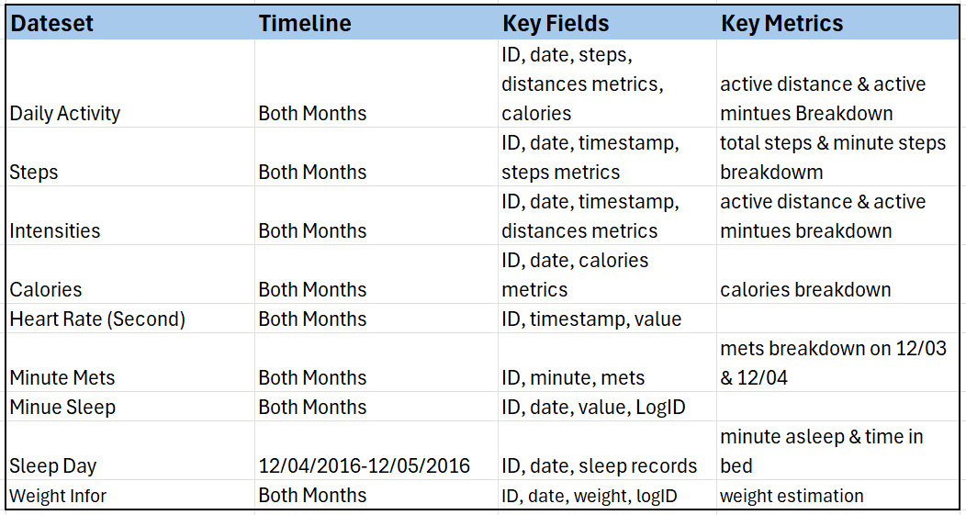
Table1. Database description

These datasets provide detailed insights into users’ activity patterns, sleep habits, and overall wellness behaviours. Although the data does not come from Bellabeat users directly, it reflects general smart-device usage patterns that can be applied to Bellabeat’s target audience.

Data Preparation & Cleaning

The data preparation and cleaning process includes following steps:
- Data import. Used R to standardise all Fitbit files and programmatically load them into a new MySQL schema with consistent table structures.
- Each table underwent a structured profiling process, including row counts, distinct-key checks, missing-value scans, date-range validation, and distribution checks. All primary tables were fully profiled, while large granular tables were profiled using representative samples.
- Performed initial cleaning and formatting, including removing duplicates, correcting inconsistent entries, and standardizing date and time formats.
- Checked for missing values, structural errors, and anomalies across activity, sleep, and daily records.
- Standardized field names and ensured consistent units across datasets.
- Created additional calculated fields (e.g., total active minutes, sleep efficiency, weekday/weekend indicators) to support downstream analysis.
- Merged datasets using appropriate keys to build a unified analytical dataset.

Market Analysis

Market Overview

The global smart wellness and wearable technology market has grown rapidly as consumers increasingly rely on devices to track activity, sleep, stress, and overall health. Within this landscape, women’s health technology has emerged as a fast-growing segment, driven by rising interest in holistic wellness and data-driven, preventive health management. Advances in sensor technology and mobile connectivity have further expanded the capabilities of smart wellness products, making personalized insights a key competitive differentiator. Operating in this environment, Bellabeat can leverage user behavior insights—particularly around activity, sleep, and wellness habits—to strengthen product positioning and enhance marketing strategy for female consumers.

Customer Analysis
Customer analysis aims to understand female users’ behaviour modelling, needs and pain points.
Activity metrics
(daily steps, active minutes, sedentary minutes, calories burned, intensity minutes). These metrics can answer question like what is users’ activity level? Is it regular?
Sleep metrics
Total sleep time, deep sleep/ light sleep / REM / sleep efficiency / sleep start time / sleep consistency
Usage metrics
Daily app usage, tracking frequency, device sync frequency, feature usage

Product & Usage Analysis
Leaf/time performance
Activity level, sleep quality, stress indicators, heart rate patterns
Spring performance
Sedentary minutes, activities
Bellabeat apps
Tracking frequency, app usage time, feature adoption

Competitive Landscape
Market share
Device adoption rate
Feature coverage
Health tracking depth
App engagement
Subscription conversion rate

Market Trends & Opportunities
Health behaviour tendency
Tendency in daily steps. Sleep tracking adoption, stress-related metrics, app usage
Female health management tendency
Opportunity
High engagement segments, low engagement segments, feature gap, potential foe subscription

Strategic Recommendations

- Next Steps

